Lesson Plan for PCCU:
Identifying Stereotypes and Biases of South Korean Culture Through Social Media

Mariel Herzog
English and History Teacher
Evergreen Academy
Union, IL

1. Reflective Essay
After attending this workshop in October of 2021, I spent some time reflecting on how stereotypes and biases are common in the culture here in the United States and how my students stereotype different groups of people without even realizing it. I also have realized that outside of the United States, many of my students have very little knowledge of different cultures and how society operates in different countries. One of the goals I have for my students is to broaden their viewpoints on preconceived stereotypes and become more aware of different cultures in present-day society outside of the U.S.
Last school year I began to introduce more lessons on stereotypes and bias in U.S. culture and how my students can become more cognizant of this in the community so they can respond effectively and appropriately. When this workshop was brought to my attention, I thought this would be a good way to extend the conversation of stereotypes to an international viewpoint since I had previously only focused on the U.S. Many of the resources I received during the workshop, including the pre-work quiz, will be helpful in explaining to my students how preconceived notions of other cultures outside of the U.S. is also a way to discriminate against other groups, even if it is done intentionally.

2. Teaching Opportunities
In the last two years, I have taken many professional development workshops on the history of Korea, trying to expand my own knowledge on the country and hoping to eventually create an elective class on this very unique topic. In the spring semester of this year, I will be piloting my first History of Korea class as part of my caseload. I have built this class to be a combination of a History and English class, focusing on Korean literature ( To Swim Across the World by Frances and Ginger Park) in a chronological time order with the history (Ancient Korea, the 1800s, and war/modern day). The resources I have been privy to during this workshop will contribute to a mini unit at the end of the semester where I can talk about common misconceptions between the U.S. and Korea and how stereotypes and biases jade many peoples’ thoughts on how culture in either country is represented.
In this lesson plan, I will be viewing these stereotypes through a mode of communication students are very familiar with: social media. This topic is not only relevant to today’s culture, but it also is something my students will be familiar with that I can use as a hook in the introduction of this lesson. I will be comparing and contrasting South Korean and American culture, as seen through social media, to show my students that many of the same issues we see through the internet here are the same as in a country halfway around the world.

3. Specific Classroom Application

Day 1
Activity #1- Introduction/ Bell Ringer (10-15 minutes)
-Response question to be answered in notebooks: If I ask you what social
identity is, how would you explain it? Do you think social identity is important when it comes to fitting in with society? Explain your answer.
-After the students have had a few minutes to independently respond, then lead
a short class discussion on the students’ answers.

Activity #2- What Is Your Social Identity? (30 minutes)
-Social Identity Worksheet: the students will fill this out independently
(Appendix B), then we will discuss together as a whole group. This discussion is to understand the social identity of the students as they fit into the society in the U.S. The following are some guiding questions for discussion:
- How does your social identity classify you in the town you live in?
- Do you feel as though your town has a diverse social identity among the people who live there? Explain.
- Would having a diverse social identity in your town be good or bad? Explain.
-We will then make some predictions about the social identity of high school students in South Korea and if the students believe it to be similar or different to our own identities. I would make a list on the board with student participation.

Activity #3- Comparing U.S. and S. Korean Social Norms (30 minutes)

-We would then take a quiz that compares our United States emotions and thoughts about work and society to those of South Koreans. We will follow the link below to take this test.
www.mygiide.com
-After everyone completes the test, we will discuss similarities and differences we noticed. I will ask the students if anything surprised them, hoping they will mention that there were not as many differences between the two teenage cultures as they had previously predicted.
_______________________________________________________________________

Day 2
Activity #4- Bell Ringer (10 minutes)
-Response question to be answered in notebooks: What type of social media
platform do you prefer to post on and why? If you do not have any social media,
explain your reason for not using it. How does social media fit into society in today’s digital and social age?

Activity #5- How does Social Media Play into Society? (45 minutes)
-We will dive deeper into how social media is a very important tool in South
Korean society by reading the article titled, “Social Media Usage in South Korea in 2020.” (Appendix A)
-We will read and annotate this article together, but the students will fill in the Summarizing Worksheet (Appendix C) themselves as we read through it.
Some of the main points we will discuss:
- Differences/ similarities between social media platforms in the U.S. and S. Korea.
- Compare/contrast usage time between the two countries.
- Societal response
- The pros and cons of social media on the life of teenagers.

Activity #6- Identifying Stereotypes (20 minutes)
-After we have read over the article, we will then create a Padlet of stereotypes that we can rule out when it comes to South Korea and social media. I will have the students post their responses of different stereotypes we have debunked as we discuss them further.
____________________________________________________________________
Day 3
Activity #7- Assessment- Google Slides Presentation
-To end this mini lesson, the students will be responsible for creating a Google Slide presentation on one of the social media platforms that is popular and well-used in South Korea (this information was obtained from the article we read the day before). The students will pick one of the topics below and compare and contrast U.S. and S. Korean stereotypes based on the central topic:
- How Much Influence Does The Public Have On The Content They Watch or Listen To?
- How To Use Social Media For Your Advantage When It Comes To Businesses
- Ways Parents Monitor Their Kids’ Social Media Accounts
- The Effect of Social Media In Connecting People
- The Impact of Social Media In Behaviour Changes in Children
- The Effect of Social Media In Creating Rifts Amongst People
- The Role of Social Media In Everyday Life
- How Is the Prevalence of Identity Theft in the Age of Social Media
- Social Media and Mental Health Issues
- Can Social Media Become Addictive?

Because research will be involved, the students will have two days to work on their projects before presenting to the class.

4. Illinois State Standards
- Constructing Supporting Questions
SS.IS.2.9-12: Explain how supporting questions contribute to an inquiry.
- Determining Helpful Sources
SS.IS.3.9-12: Develop new supporting and essential questions through investigations, collaboration, and using diverse sources.
- Global Interconnections: Changing Spatial Patterns
SS.G.9.9-12: Describe and explain the characteristics that constitute a particular culture.
- Perspectives
SS.H.8.9-12: Analyze key historical events and contributions of individuals through a variety of perspectives, including those of historically underrepresented groups.
- Causation and Argumentation
SS.H.12.9-12: Analyze the geographic and cultural forces that have resulted in conflict and
cooperation.

5. Lesson Set-up
- High School (11-12)
- 5- 75-minute blocks (1 hour and 15 minutes each block)
  - 3 days for classwork and analysis
  - 2 days to create presentation

6. Resources
- Article: “Social Media Usage in South Korea in 2020” (Appendix A)
-https://www.interad.com/en/category/insights/social-media-korea.html
- Social Identity Worksheet- Talk About Race website (Appendix B) -https://nmaahc.si.edu/learn/talking-about-race/topics/social-identities-and-systems-oppression
- Comparing Social Norms b/w U.S. and S. Korea -www.mygiide.com
- Article Summary Worksheet (Appendix C, created on Teachers Pay Teachers)
- Group Discussion Board: Padlet.com
- Central Questions for Final Assessment https://topicsbase.com/social-media-research-paper-topics.html
- Google Slides Rubric (Appendix D) https://wbotech5.weebly.com/uploads/3/8/0/0/38003301/google_slides_rubric.pdf

Appendix A

Article: Social Media Usage in South Korea in 2020
Mariví Cervi On Jul 7th, 2020 at 04:18 am |

South Korea has long been considered an “early-adopter” of technological advances with wide-spread access to high-speed internet, and high usage of mobile internet and social media, and so it is an interesting market for foreign companies to expand into when looking for new business.
It is one of the best-connected countries in the world with the highest average internet speed worldwide and an internet penetration rate of around 96 percent in January 2020. For comparison, the global internet penetration rate in the same month was a mere 59 percent.

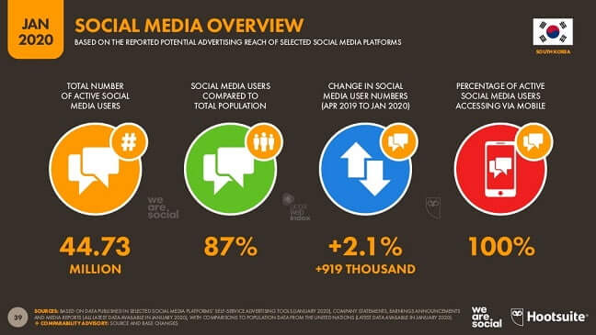
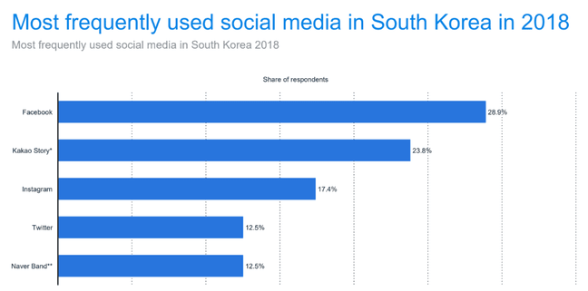
According to Datareportal, there were 49.21 million internet users in South Korea in January 2020, and the number of internet users in South Korea increased by 535 thousand (+1.1%) between 2019 and 2020. For a country with such good internet infrastructure, we would expect to see high engagement with social media platforms, which is very much the case. In the same month, January 2020, there were reportedly 44.73 million social media users in the county, and the number of social media users increased by 919 thousand (+2.1%) between April 2019 and January 2020, with a social media penetration rate of 87 percent. That might be the reason that many foreign companies are looking to hire Online Marketing Services to penetrate in the Korean Market.

Most Popular Social Media Platforms in South Korea
While the usual social media platforms all have a presence in South Korea, the country is home to several networks that might seem less familiar. Many of them may have similar features to more common platforms but they also sport some more innovative features that were developed as a way to stay ahead of interlopers from the United States and elsewhere. For example, Daum/KakaoTalk is the result of the merger of two major Korean digital service providers and has successfully carved out a sizeable chunk in the market.

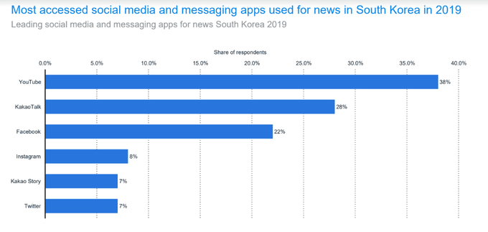
In 2018, Facebook proved to be the most frequently used social media platform in South Korea but KakaoStory was the next in line, ranking ahead of international social media giants Twitter and Instagram. KakaoStory is a similar platform to Facebook and provides a plethora of services, and exists alongside KakaoTalk, a WhatsApp-style messaging service, which is actively used by 97% of all smartphone users in Korea and serves more than 43 million monthly active users. Like the Chinese WeChat, Kakao has since engaged in a diversification strategy, offering online banking and taxi services, for example, and Kakao users are also able to send each other gifts. In 2019, KakaoTalk ranked as the second most accessed social media or messaging app used for news in South Korea, after Google’s YouTube video sharing platform.

South Korea’s most popular search engine, NAVER, has a variety of different products on offer, including a communication app for teams and groups called BAND. In the US, it’s marketed as something closer to a business tool, like Slack, but it become popular in South Korea via the gaming community, which used it as a way to talk online when users were playing games in teams. South Korea’s love of social media can be traced to Cyworld. Created in 1999, way back before Facebook and Twitter, Cyworld was the first major social media network and a huge hit in South Korea. One of its unique features is that it allows its users to organise, manage and prioritise their relationships according to a hierarchy consisting of three different “ranks”, matching the structure of Korean society.

Businesses looking to expand overseas into countries with new and exciting marketing opportunities would do well to note South Korea’s love of social media and high mobile internet usage. Korean marketers have noticed a rise in the demand for Social Media Services such as Instagram and Facebook Ads and account management. In January 2020, there were around 60.61 million mobile connections in the country, and the number of mobile connections in South Korea increased by 699 thousand (+1.2%) between January 2019 and January 2020. The number of mobile connections in South Korea that month was equivalent to 118 percent of the total population. A market with a huge audience that is already heavily engaged with social media and mobile internet provides opportunities to play with new types of video marketing, search engine optimization and programmatic advertising.

It wasn’t long ago that the South Korean market was dominated by domestic social media platforms but Facebook claimed that top spot over the last few years and in 2020, the platform had 15.13 million users in South Korea alone. Overall, this could suggest that South Korean social media platforms are in trouble; as young people get smartphones, they join Western platforms like Facebook and Instagram instead. In 2019, the share of social media users who used Facebook in South Korea aged between 10 and 19 was 84.1 percent, compared to just 50 percent of those over 50. However, it might just mean that – as in most Western countries – some social media networks are just more suited to some demographics than others. BAND, for example, may appeal more directly to users who need slightly more professional elements, with its shared calendars, user polls and an inherent organization that benefits older users.

https://www.interad.com/en/category/insights/social-media-korea.html

Appendix B
Social Identity Worksheet

The purpose of this exercise is to map out different domains of your social identity (i.e., social group membership) and to reflect on how these domains intersect with one another to shape your life experiences. We are socialized into seeing oppressive social relations and structures (e.g., personal bias, social prejudice, institutional discrimination, inequitable social structures) based on social group memberships as natural and normal. As McIntosh (2003) describes her white privilege as, “an invisible package of unearned assets which I can count on cashing in each day, but about which I was ‘meant’ to remain oblivious” (p. 191), when we belong to a privileged social group, it is especially difficult to recognize our own privilege. Privilege is often unearned, unasked for, and invisible benefits and advantages available to members of the privileged group (Hardiman, Jackson, & Griffin, 2007).

The goal of this exercise is not to assess how privileged or marginalized you are. The exercise does not fully capture or define who you are, and doing so is not its goal, either. Almost all of us have some experiences of privilege and some of marginalization, and these experiences are relative to context. In addition, different social identities will be perceived more or less salient to yourself and others, influencing your worldviews and interpersonal interactions, and what becomes more or less salient depends on the context (Sensoy & DiAngelo, 2012; Tharp, 2012). For example, a white working-class male may experience marginalization in Canadian society because of his socio-economic class, but his socio-economic condition may be still privileged relative to another country setting. In another setting, his race may become a more salient aspect of his identity than class.

Moreover, it is important to be mindful of the intersectional nature of our social identities (Hardiman et al., 2007; Sensoy & DiAngelo, 2012). One aspect of our identity seldom acts independent of the other aspects. Rather, different aspects of our identity interrelate with one another to shape a unique experience for each of us. In other words, those who share one identity domain, such as all those who are male, do not necessarily experience male privilege in the same way or extent because of the other identity domains that they do not share.

Despite these complexities of our social identities, we need to begin with articulating and reflecting on implicit, as well as explicit, domains of our identity to understand how we are positioned in society and how it shapes our life experience.

Instructions
1. Write your identity in Column B corresponding to each identity domain in Column A.
2. In the top row on Column C, write the places where you live now (and lived as a child,
if it is different from where you live now).
3. For each identity domain on Column B, consider if it puts you in a position of privilege
or marginalization. Write “P” for privilege and “M” for marginalization on Column C.
4. Proceed to Reflection Questions.

Note: This identity mapping table was adopted from “A Map of Myself” by Harlap (2008). 1 “Race is a socially constructed system of classifying humans based on phenotypical characteristics (skin color, hair texture, and bone structure)” (Sensoy & DiAngelo, 2012, pp. 22– 23). 2 “Ethnicity refers to people bound by a common language, culture, spiritual tradition, and/or ancestry. Ethnic groups can bridge national borders and still be one group . . . At the same time, ethnic groups can live within the same national borders and not share the same ethnic identity” (Sensoy & DiAngelo, 2012, p. 23). 3 Gender expression is the gender that a person presents to the world. Gender identity is the gender that a person feels inside. Gender expression and gender identity often correspond with biological sex, but this is not the case for all people.

A Map of Myself
A. Domains | B. My identity/ identities | C. Does this identity give me a position of privilege (P) or marginalization (M) relative to most people in:
 |  | The place I live now [ ] | The place I lived as a child [ ]
Race (e.g., white, black, biracial)
Ethnicity (e.g., Chinese, Welsh, Cree, Inuit, Métis)
Biological sex (e.g., male, female, intersex)
Gender identity/expression3 (e.g., women, men, transgender)
Sexual orientation (e.g., lesbian, gay, heterosexual, bisexual)
Religion
Socio-economic class (e.g., owning, middle, working class)
Dis/ability (e.g., able-bodied, disabled)
First language
Other [ ]

Reflection Questions

1. Considering all your social identities listed in the table above, on a daily basis, which ones are you most aware or conscious of? You can pick more than one domain if you want.

a) Most aware/conscious of:

b) What do you appreciate about or gain from that identity?

c) What is the most negative or difficult thing about that identity?

2. Considering all your social identities listed in the table above, on a daily basis, which ones are you least aware or conscious of? You can pick more than one domain if you want.

a) Least aware/conscious of:

b) What do you appreciate about or gain from that identity?

c) What is the most negative or difficult thing about that identity?

3. What stood out most to you in this exercise? Why?

4. What would you like to know more about or explore further?

Note: These reflection questions were adopted from Diane J. Goodman (dianejgood@aol.com) and UBC Peer Program Training Modules: Diversity & Intercultural Communication 2008/09. Time and Place at UBC: Our Histories and Relations - http://timeandplace.ubc.ca/ User Guide for Educators – Appendix 2 Licensed under a Creative Commons Attribution-NonCommercial-ShareAlike 4.0 International License.

Appendix C
Name: _____________________ Period:______
ARTICLE WORKSHEET
DATE DUE:________
Directions: Find an article either in the newspaper or online from a credible news source (Time.com, CNN students news, USA Today, The New York Times, MSN, Google, or any other reputable national or local source). Read the article and fill out the prompts below. You may not use articles on Entertainment/Gossip. Please find and read about important issues in our world today. Because this is a current events assignment you are to choose an article that is no more than a week old from when the assignment is given. Attach the printed off article to the worksheet.
Topic of Article: ___________________________________________________________________ Title of Article: _____________________________________________________________________ Source: ____________________________________________________________________________
WHO is this article about? ____________________________________________________________________________________________________________________________________________________________________________________________________________________________________________________________
WHAT is this story about; SUMMARIZE four important facts from your article.
1. _________________________________________________________________________________ ________________________________________________________________________________________________________________________________________________________________________________________________________________________________________________________________________________________________________________________________________2. _________________________________________________________________________________
________________________________________________________________________________________________________________________________________________________________________________________________________________________________________________________________________________________________________________________________________ 3. _________________________________________________________________________________ __________________________________________________________________________________________________________________________________________________________________________________________________________________________________________________________________________________________________________________________________________________________________________________________________________________________
4. _________________________________________________________________________________ ________________________________________________________________________________________________________________________________________________________________________________________________________________________________________________________________________________________________________________________________________
WHEN did this story take place? / WHERE is this event or issue occurring? (Specify city, country, region, etc.)
____________________________________________________________________________________________________________________________________________________________________________________________________________________________________________________________

WHY is this story important?
________________________________________________________________________________________________________________________________________________________________________________________________________________________________________________________________________________________________________________________________________________________________________________________________________________________________________________________________________________________________________________________________________________________________________________________________________________________________________________________________________________________________________________________________________________________________________________________________________________________________________________________________________

CONNECT to the article. (What does it have to do with you? Can it be connected to anything we learned or are learning about in class? How does this impact your life?) ____________________________________________________________________________________________________________________________________________________________________________________________________________________________________________________________________________________________________________________________________________________________________________________________________________________________________________________________________________________________________________________________________________________________________________________________________________
Appendix D
Google Presentation Rubric

